B.E. PROJECT ON

**Minimum Viable Product Generator**

SUBMITTED IN PARTIAL FULFILLMENT OF REQUIREMENTS OF AWARD OF

B.E. (COMPUTER ENGINEERING)

DEGREE OF UNIVERSITY OF DELHI

SUBMITTED BY:

Akanshi Gupta 216/CO/12

Chitrasoma Singh 254/CO/12

Divjot Singh 262/CO/12

GUIDED BY:

Dr. Sushma Nagpal



COMPUTER ENGINEERING (COE)

NETAJI SUBHAS INSTITUTE OF TECHNOLOGY

UNIVERSITY OF DELHI

2012-16



**CERTIFICATE**

The project titled **“Minimum Viable Product Generator”** by **Akanshi Gupta (216/CO/12), Chitrasoma Singh (254/CO/12) and Divjot Singh (262/CO/12)** is a record of bonafide work carried out by them, in the Division of Computer Engineering, Netaji Subhas Institute of Technology, New Delhi, under the supervision and guidance of Dr. Sushma Nagpal in partial fulfilment of requirement for the award of the degree of Bachelor of Engineering in Computer Engineering, University of Delhi in the academic year 2015 - 2016.

**Dr. Sushma Nagpal**   
Division of Computer Engineering   
Netaji Subhas Institute of Technology   
New Delhi

Dated:

**CANDIDATES’ DECLARATION**

This is to certify that the work which is being hereby presented by us in this project titled “**Minimum Viable Product Generator**” in partial fulfilment of the award of the Bachelor of Engineering submitted at the Department of Computer Engineering , Netaji Subhas Institute of Technology Delhi, is a genuine account of our work carried out during the period from January 2016 to May 2016 under the guidance of Dr. Sushma Nagpal, Department of Computer Engineering, Netaji Subhas Institute of Technology, Delhi. The matter embodied in the project report to the best of our knowledge has not been submitted for the award of any other degree elsewhere.

Dated:

|  |  |  |
| --- | --- | --- |
| Akanshi Gupta | Chitrasoma Singh | Divjot Singh |

This is to certify that the above declaration by the students is true to the best of my knowledge.

Dr. Sushma Nagpal

**ACKNOWLEDGEMENT**

No significant achievement can be done by solo performance especially when starting a project from ground up. This B.E. Project, on such a revolutionary idea, has by no means been an exception. It took many very special people to enable it and support it. Here we would like to acknowledge their precious co-operation and express our sincere gratitude to them.

**Dr. Sushma Nagpal** has again been very supportive and involved in yetanother student project. It was her support that helped the project to start in its earliest and most vulnerable stages. Her name opened many doors for us and persuaded many people. She was always found with energy and enthusiasm to make sure that we were provided everything we needed. No amount of words can express thanks to her. She was the one who backed us in providing any assistance we needed during the project work.

We are also thankful to our friends who motivated us at each and every step of this project. Without their interest in our project we could not have been gone so far.

And the most of all, we would like to thanks our wonderful parents who motivated us from day one of the project. You were the lights that lead us.

It was a great pleasure and honour to spend our time with all of them and there could be no better payment for the efforts put into completing this B.E. Project than their valuable presence. They are all very special to us.

**ABSTRACT**

Digital world is undergoing and experiencing the biggest change in the history, with not only the internet reaching almost every corner of the world, but also with the increasing use of web and mobile apps more than ever. New start-up ideas are evolving to make almost all services like entertainment, socializing, shopping, payments etc. just a click away through them. Application development for these platforms requires a talented team of software engineers working on each part of the software stack. This requires a lot of capital that is usually not available with start-ups initially.

Application developers have started focusing on developing search engines apart from traditional applications. They are focused search engines for entities like doctors, restaurants, movie bookings, service workers etc. A common pattern has been observed in their functionality that provides a great room for automation in their development process. MVP Generator focuses on automating this process, using component driven and agile software development methods to achieve high level of modularity. This can help the startups in saving cost and time, getting funds early and provide boilerplate code to experienced teams to work on.

**TABLE OF CONTENTS**

1. Detailed Problem Statement

1.1. Introduction

1.2. Motivation

1.3. Problem Statement

1.4. Definitions

1. Literature Survey
2. Software Requirement Specification
   1. Introduction

3.1.1. Purpose

3.1.2. Scope

3.1.3. Technologies Used

3.1.4. Overview

3.2. Overall Description

3.2.1. Product perspective

3.2.2. Product functions

3.2.3. User characteristics

3.2.4. Constraints

3.2.5. Assumptions

3.3. Specific Requirements

3.3.1. External Interface Requirements

3.3.2. Functional Requirements

3.3.3. Performance Requirements

3.3.4. Design Constraints

3.3.5. Non Functional Requirements

3.3.6. Other Requirements

3.4. Change Management Process

4. Model Proposed

5. Conclusion and Results

5.1. Result

5.2. Conclusion

6. Future Scope

7. References

**LIST OF FIGURES**

|  |  |
| --- | --- |
| Figure No | Description |
| 1 | Application Workflow |
| 2 | Caption2 |
| 3 | Rendering and State Management in React |
| 4 | Creation of DOM Tree |
| 5 | Caption5 |
| 6 | Working of NodeJS |
| 7 | Context diagram of MVP Generator |
| 8 | Layers in MVP Generator |
| 9 | ER Diagram of the skeleton for generator |
| 10 | Component tree of the entity page |

**Chapter 1  
Detailed Problem Statement**

1.1. Introduction

1.2. Motivation

1.3. Problem Statement

1.4. Definitions

* 1. **Introduction**

With internet reaching the next billion people, new startup ideas are evolving to provide more services on the backbone of internet and smartphones. We are probably witnessing the biggest shift in technology since the emergence of internet. The use of web and mobile apps is growing at a tempestuous pace. [1] As a matter of fact, apart from games and content consuming applications, search engines are a major part of application industry. From finding restaurant [2] to finding doctors [3], there’s an app for that. Digital world is progressively playing an important role in people’s lives as web and mobile apps are used more than ever for entertainment, socializing, shopping and payment purposes.

However, these applications aren’t as simple as static websites of 2000s. These often have a cloud-computing backed data-store, a server equipped with load-balancers, and complex UI loading content dynamically using swift HTTP transfers. The development of such an application usually requires a team of software engineers working on each part of the software stack. This isn’t a big problem for established companies with enough capital to invest in such applications, however being seed funded on basis of quality of Minimum Viable Product (MVP) is the only chance for a startup to break ice in the industry.

From application stores of mobile operating systems like iOS and Android, we observed that a good share of applications follow a common pattern when it comes to functionality. They are essentially focussed search engines for entities like restaurants, doctors, service workers etc. This pattern makes room for some automation in development process, which can not only help startups to get funded early, but also assist experienced teams with some boilerplate code to work on.

MVP Generator aims to do the same with the help of component driven development [4], industry best practices, and use of latest technology stacks that assure high level of modularity with good performance in order to generator such MVPs based on descriptions given about the entity their focussed search engine application is about.

* 1. **Motivation**

Modern lifestyle is being shaped by internet and mobile applications. Our initial survey of top 50 applications in Apple App Store and Google Play Store showed that 10% of applications are search engines. Applications like restaurant finder [2], car reviews [4], service worker finders [3] are top in that list.

Often, such applications have a web application too, for desktop and laptop users. We observed that they all have common user interface involving following primary screens:

* Home feed showing popular or trending entities
* Entity page with reviews made by registered users
* Search page allowing users to use filters to fetch desired entity

Our case study of a few such popular applications highlights these features very well.

We’ll go through following Applications’ functionalities and user interfaces to understand what facilities they provide:

1. Zomato (Restaurant Finder)
2. Practo (Doctor Finder)
3. Urban Clap (Service Worker Finder)
4. BookMyShow (Movie Booking)
5. **Zomato (Restaurant Finder)**

Zomato is a restaurant search and discovery app and website, providing in-depth information for over 1.4 million restaurants across 23 countries. Zomato is used by consumers globally to discover, rate and review restaurants, as well as create their own personal network of foodies for trusted recommendations. It lets its users to search for meals through a number of filters, including location, price, cuisine, etc.

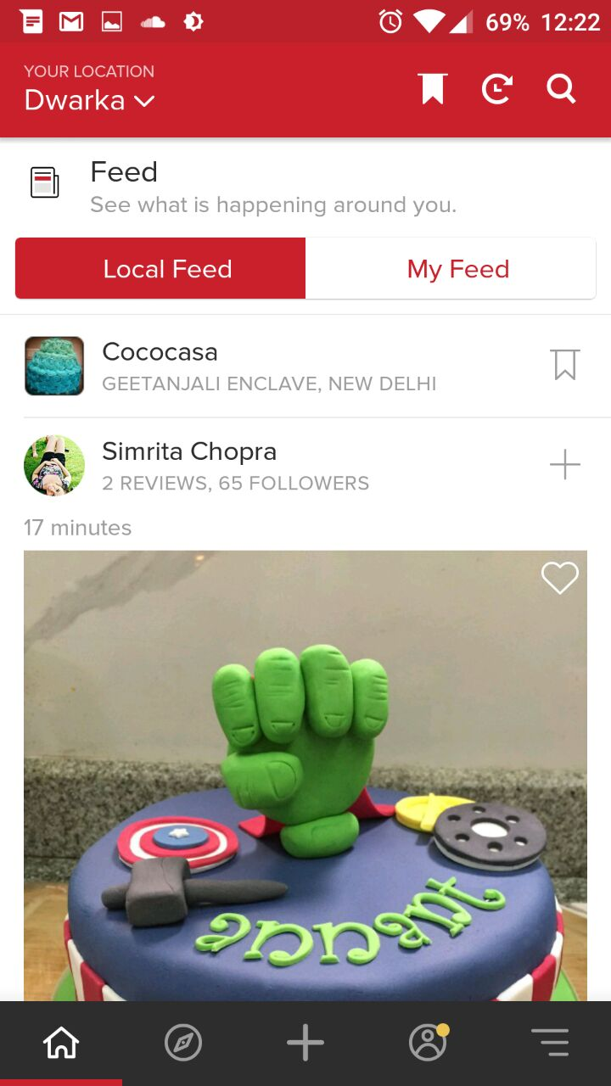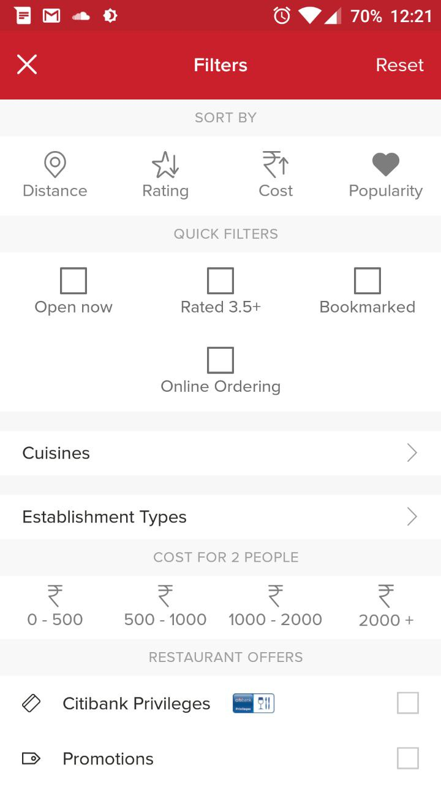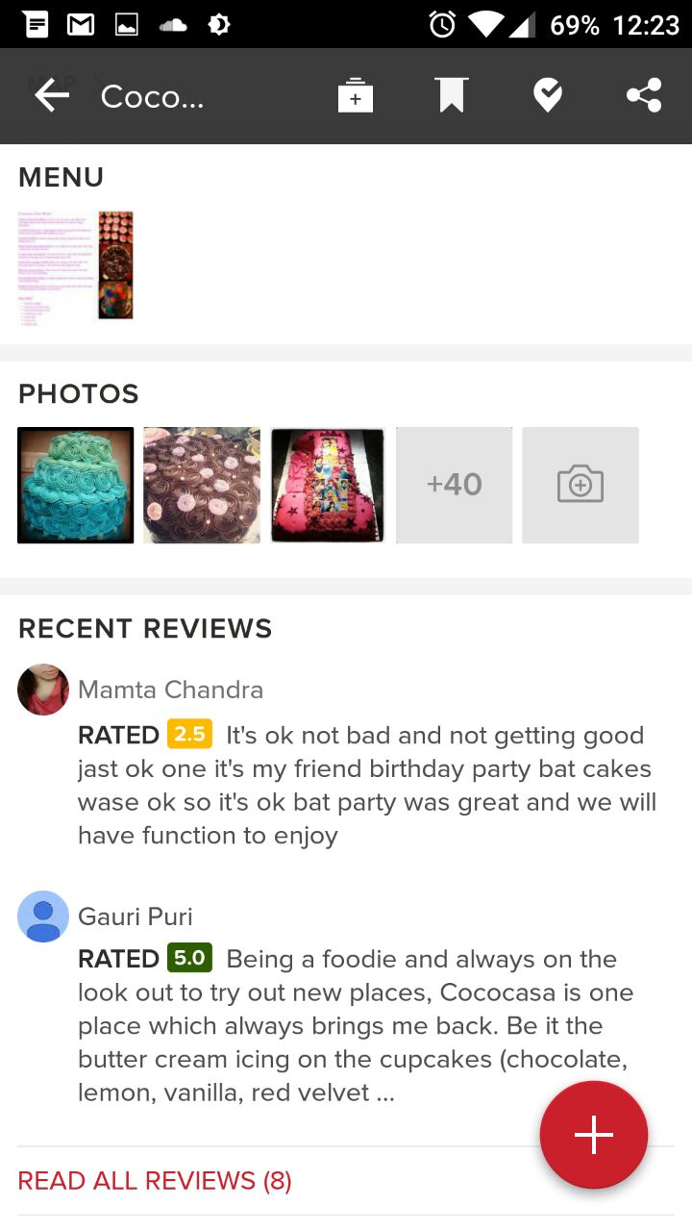

**Functionality 1 (Feed):**The user interface has a home feed showing “cards” of each entity in a scrollable list. Review stars are displayed in each card.

**Functionality 2 (Search):** There’s a search page which allows users to search restaurants based on applied filters.

**Functionality 3 (Reviews):** Registered users can review the restaurants as well. A list of reviewsis displayed.

**Functionality 4 (Entity Page):** User can tap on a card to open the restaurant page which has additional details like phone number, menu, location etc.

1. **Practo (Doctor Finder)**

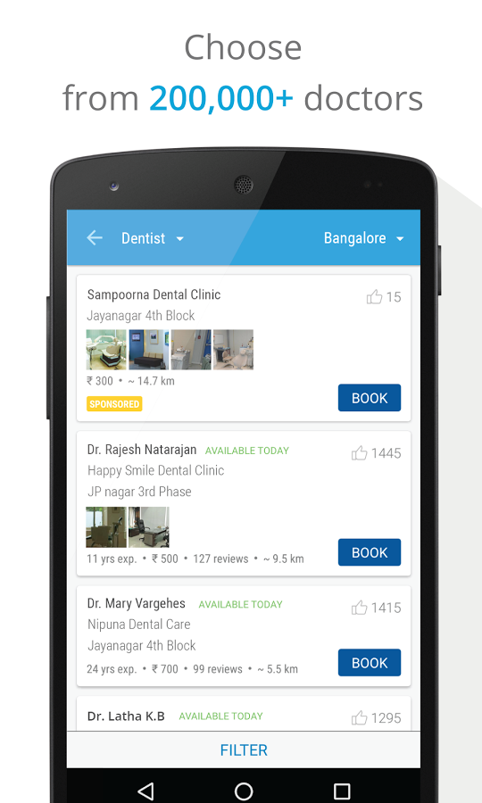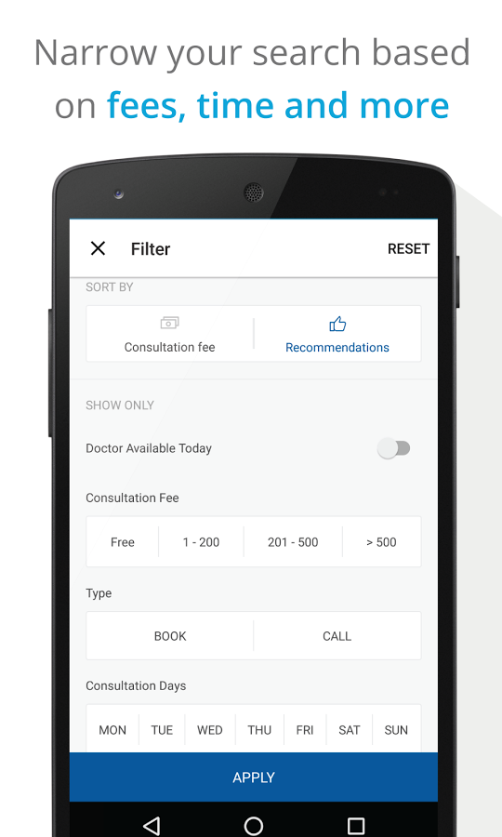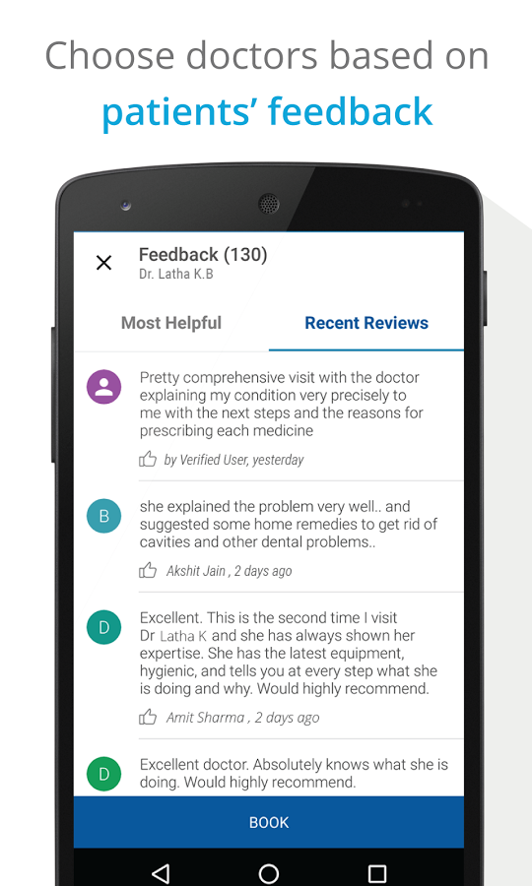

**Practo** is a ‘Health and Fitness’ app which can be used to "search" doctors and clinics in your city and book appointments on the go. Practo Search, a doctor search engine, and Practo Ray, a B2B software product help doctors manage large number of patients and digital healthcare records every year.

**Functionality 1 (Feed):** By clicking on a card, users are directed to the page that contains complete details of the doctor, the appointment slots available and information about other hospitals where the doctor practices.

**Functionality 2 (Search):** The search is quite refined with scrolling cards of docters with various fields like experience, consultation fee, pictures (for some), address, like button, customers feedbacks. It lets users search for doctors or clinics which they know or want to know about.

**Functionality 3 (Reviews):** Practo provides a personalised dashboard to each user to keep track of his/her appointments and reviews about the doctors.

**Functionality 4 (Entity Page):** Users can select from around 200 specialists around their city. This feature has a decent number of search results showing up under most of the cities and a counter at the top right corner of the window is also seen.

1. **Urbanclap (Service Worker Finder)**

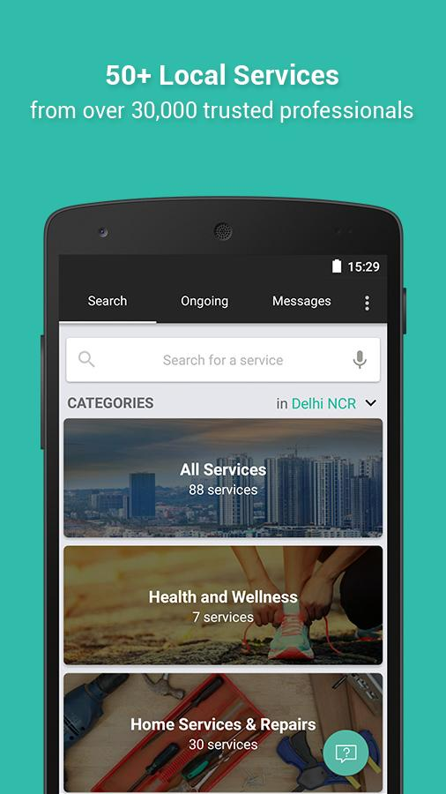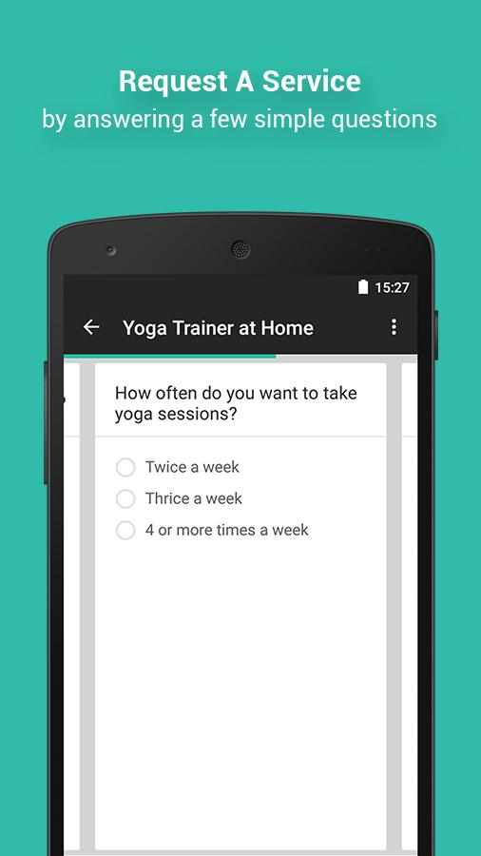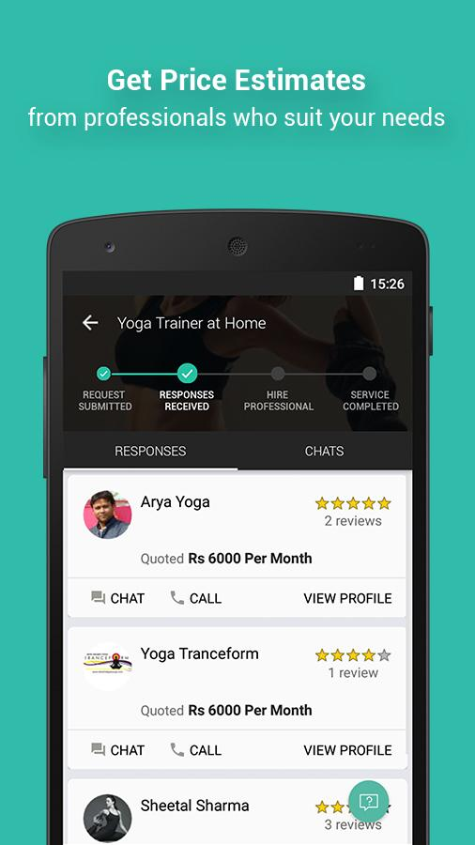

**UrbanClap** is an app-based service marketplace that connects customers to service professionals. UrbanClap enables users "search" for any service professional like a plumber, a wedding photographer, a yoga teacher, or an interior designer. They want to be the go-to platform helping customers complete projects that are important to their urban lives – everything from designing their homes to capturing key moments, learning arts, filing taxes, and getting healthier etc. The company claims to have 1000+ highly engaged service providers on the platform through whom they are connected to multiple 1000 professionals.

This has a different design but similar functionalities as above examples.

**Functionality 1 (Feed):** Users can specify thetimings, location and budget range. They receive response within a few hours.

**Functionality 2 (Search):** All the requests appear under the projects tab. Users can manage multiple projects together. Users can choose the desired service provider from the list.

**Functionality 3 (Reviews):** Reviews and ratings from the customers help in choosing the service provider.

**Functionality 4 (Entity Page):** Users can select their city and required service.

1. **Bookmyshow (Movie Booking App)**

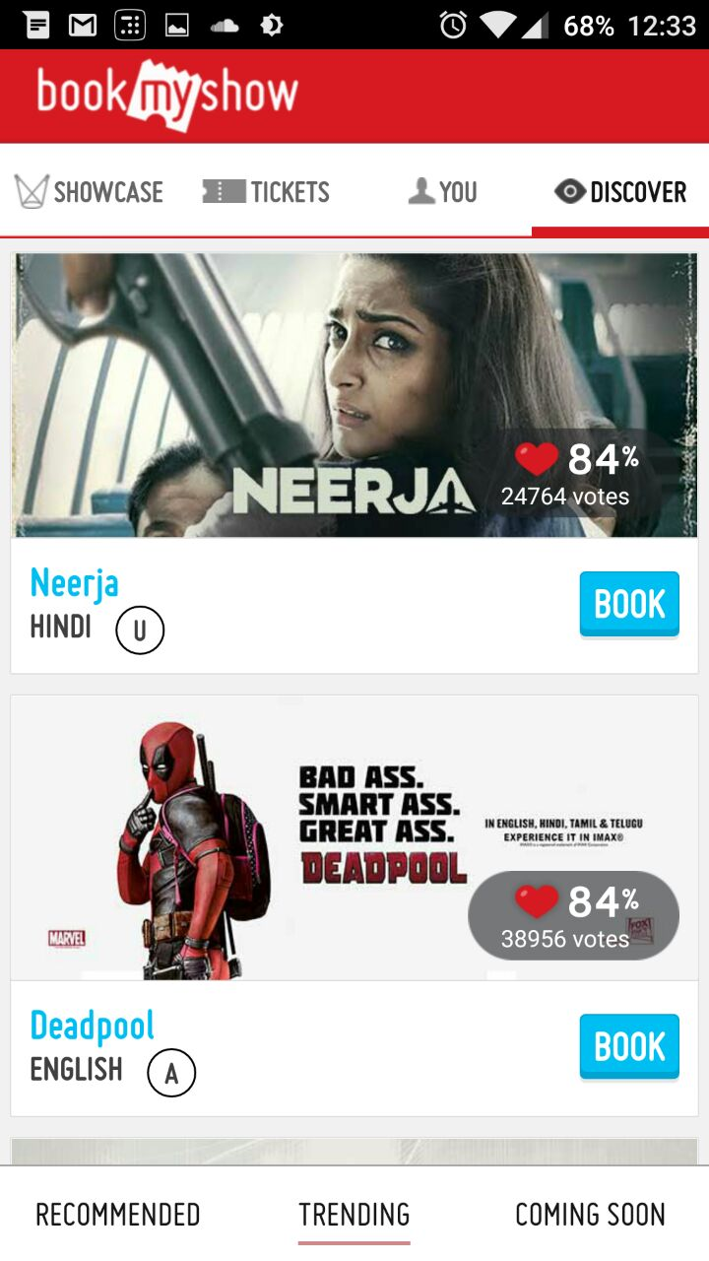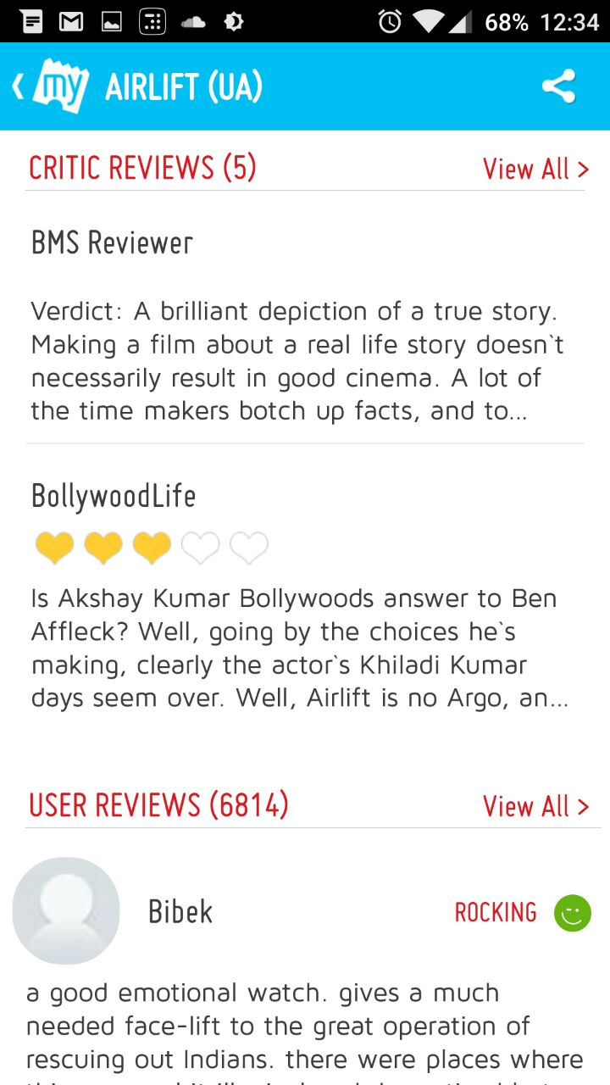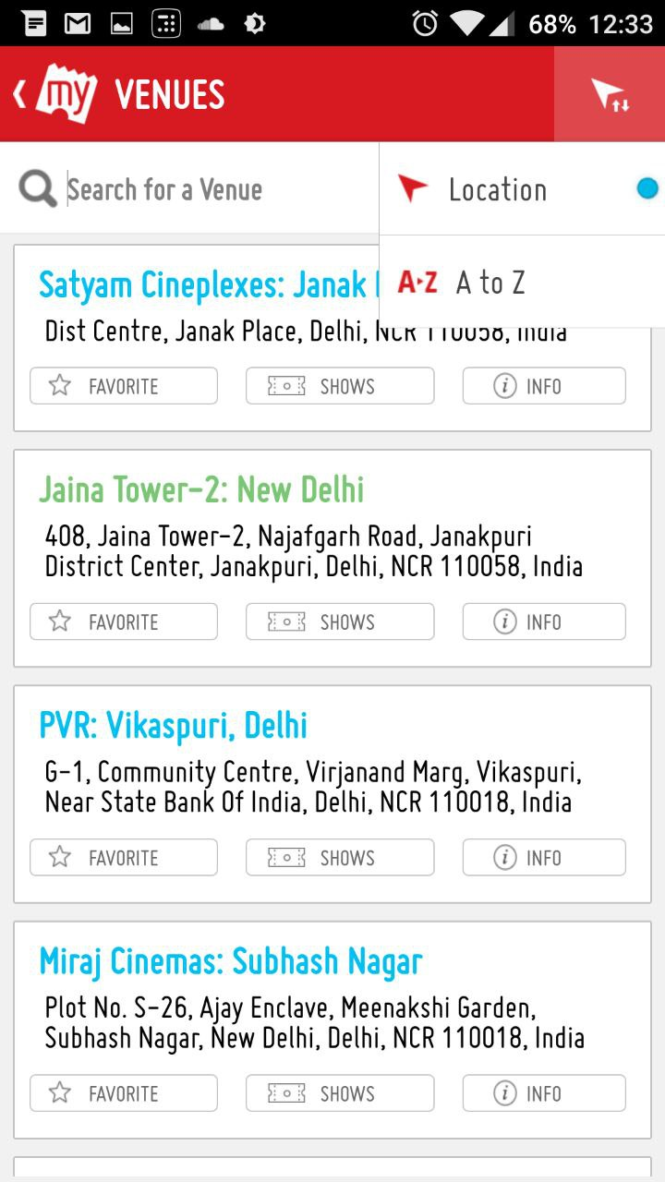

**BookMyShow** is India's biggest online movie and events ticketing brand. The website caters to ticket "search" and sales for movies, plays, concerts and sporting events via the online platform. Apart from being an online ticketing portal, BookMyShow offers information about upcoming movies and events, show timings, venue details and artist bios.

**Functionality 1 (Feed):** Users can select what they want to book, whether movies, plays, concerts etc. on choosing ‘movies’, a list of movies running near the user is displayed. On selecting the desired movie from the list, users get details of the movie like release date, run time, trailer, cost etc.

**Functionality 2 (Search):** On clicking ‘Book’, users are shown a list of theatres where they can watch the movies and the dates on which they can watch the movies.

**Functionality 3 (Reviews):** User reviews of all events (movies, plays etc.) are visible.

**Functionality 4 (Entity Page):** Users can select the city in which they want to book the tickets by selecting the ‘Search by Venue’ option or else it detects their city with the help of GPS of their device.

These common features in search centric applications yet diverse deployment devices show how a project manager needs a developer for each mobile platform, one for web development and one for backend which ties everything together. This is all just to build a Minimum Viable Product. The pattern allows us to use automation techniques to cater this niche yet huge segment of applications, which ultimately led to idea of creating MVP Generator.

|  |  |  |  |  |
| --- | --- | --- | --- | --- |
| Application/Features | Home Feed | Reviews | Searching | Elaborate Filters |
| Zomato | YES | YES | YES | YES |
| Practo | YES | YES | YES | YES |
| Urban Clap |  |  |  |  |
| BookMyShow | YES | YES | YES | YES |

* 1. **Problem Statement**

Develop a code generator program that generates an application for search centric services. The generator accepts inputs from user like application name, system details, and description of the entity around which the application is to be built, provided as a configuration file. The generator should work on Linux and OSX systems at least.

Generated code should be modular enough so that user can tweak it with minimum file changes. The cohesion should be high for the modules.

**INPUT TO THE SYSTEM**

A list of inputs like:

* Application name
* Name of entity
* Theme of application
* Database details
* Etc.

And a configuration file with details of search filters and attributes of entity that are unique to it.

**OUTPUT FROM THE SYSTEM**

A folder is to be created with server and application source code that works as per the inputs given by user.

* 1. **Definitions**

|  |  |
| --- | --- |
| **Word** | **Meaning** |
| Cohesion | Cohesion refers to the degree to which the elements of a module belong together. Thus, cohesion measures the strength of relationship between pieces of functionality within a given module. |
| URL | A Uniform Resource Locator (URL), commonly informally termed as a web address is a reference to a web resource that specifies its location on a computer network and a mechanism for retrieving it. |
| API | In computer programming, an application programming interface (API) is a set of routines, protocols, and tools for building software and applications. |
| ORM | Object-relational mapping in computer science is a programming technique for converting data between incompatible type systems in object-oriented programming languages. This creates, in effect, a "virtual object database" that can be used from within the programming language. |
| DOM | The Document Object Model (DOM) is a cross-platform and language-independent convention for representing and interacting with objects in HTML, XHTML, and XML documents. The nodes of every document are organized in a tree structure, called the DOM tree. Objects in the DOM tree may be addressed and manipulated by using methods on the objects. |
| Pure Function | In computer programming, a function may be considered a pure function if both of the following statements about the function hold:   1. The function always evaluates the same result value given the same argument value(s). 2. Evaluation of the result does not cause any semantically observable side effect or output, such as mutation of mutable objects or output to I/O devices. |
|  |  |

**Chapter 2**

**Literature Survey**

2.1. Application Development

2.2. Component Based Software Development

2.3. Agile Software Development

2.4. React

2.5. Redux

2.6. NodeJS

2.7. Express

**2.1. Application Development**

Application development is a big software engineering task involving processes like prototyping, server development, database management, testing and so on. Often the development process is layered and divided into modules that are cohesive and with low coupling. This ensures high flexibility and code readability, which helps in maintenance and migration from one platform to another over the course of the application.



**Fig 1: Application Workflow**

The development process is initially subdivided as frontend (client side) and backend (server side) development. Frontend development deals with user and interactions with layout and user interface of the application:

1. Frontend: User interface is built using some toolkit that can help in rendering them as per the designs. Hyper Text Markup Language (HTML) and Cascading Style Sheets (CSS) help in building User Interfaces (UIs) in web domain, while each mobile application ecosystem has its own rendering logics. The UI is further composed of components that interact with the components or the server (backend). A user triggers events using these components. For backend interactions, applications communicate using Hyper Text Transfer Protocol (HTTP) requests. A payload is sent in the HTTP message, often in JavaScript Object Notation (JSON) in modern applications. This is the boundary of frontend.
2. Backend: This is the server side, which is an ongoing application on a remote machine which listens for HTTP requests on a certain port number, usually 80 for HTTP applications. Upon receiving requests, server processes it and responds back to client. Server code is again subdivided into software modules that are highly cohesive in nature for better software maintainability. There’s often a router layer that deals with routing different requests for different URLs to different functions of different modules. Usually these modules lie in the API layer. Often an ORM is used to handle database queries in a manageable way.

The two ends are core parts of application development. We’ll go through development strategies used for high maintainability and flexibility in industry.

**2.2. Component Based Software Development**

Component-based development (CBD) is a procedure that accentuates the design and development of computer-based systems with the help of reusable software components. With CBD, the focus shifts from software programming to software system composing.

The process of component- and component-based system development differs in many significant ways from the “classical” development process of software systems. The main difference is in the separation of the development process of components from the development process of systems. [5] This fact has a significant impact on the development process. Since the component-based approach is a relatively young approach in software engineering, the main emphasis in the area has been in development of technologies.

Component-based development techniques involve procedures for developing software systems by choosing ideal off-the-shelf components and then assembling them using a well-defined software architecture. With the systematic reuse of coarse-grained components, CBD intends to deliver better quality and output.

Component-based development is also known as component-based software engineering (CBSE).

Component-based development techniques consist of non-conventional development routines, including component evaluation, component retrieval, etc. It is important that the CBD is carried out within a middleware infrastructure that supports the process, for example, Enterprise Java Beans.

The key goals of CBD are as follows:

* Save time and money when building large and complex systems: Developing complex software systems with the help of off-the-shelf components helps reduce software development time substantially. Function points or similar techniques can be used to verify the affordability of the existing method.
* Enhance the software quality: The component quality is the key factor behind the enhancement of software quality.
* Detect defects within the systems: The CBD strategy supports fault detection by testing the components; however, finding the source of defects is challenging in CBD.

Some advantages of CBD include:

* Minimized delivery:
  + Search in component catalogs
  + Recycling of pre-fabricated components
* Improved efficiency:
  + Developers concentrate on application development
* Improved quality:
  + Component developers can permit additional time to ensure quality
* Minimized expenditures

**2.3. Agile Software Development**

Software development is an organized thrives to deliver products in faster, better and cheaper ways. There have been many studies and suggestion in improving the development process. Recently, this interest has paved way to a new software development method called Agile Software Development. To overcome the fast changing organizational business needs using traditional methods agile methods were introduced. Agile methods aid in and focus on developing solutions more quickly and efficiently. Agile methods highlight customer satisfaction by structuring the development process into iterations where in each iteration produces sizeable amount of working code and artifacts of interest to customers. [6] It‘s a set of software development methods based on iterative and incremental development process, where requirements and development evolve through collaboration between self-organizing, cross-functional teams that allows rapid delivery of high quality software to meet customer needs and also accommodate changes in the requirements.[7] Compared to traditional software engineering, agile software development mainly targets complex systems and projects with dynamic, non-deterministic and non-linear characteristics, where accurate estimates, stable plans, and predictions are often hard to get in early stages—and big up-front designs and arrangements would probably cause a lot of waste, i.e., are not economically sound.

The Agile Manifesto is based on twelve principles: [8]

1. Customer satisfaction by early and continuous delivery of valuable software
2. Welcome changing requirements, even in late development
3. Working software is delivered frequently (weeks rather than months)
4. Close, daily cooperation between business people and developers
5. Projects are built around motivated individuals, who should be trusted
6. Face-to-face conversation is the best form of communication (co-location)
7. Working software is the principal measure of progress
8. Sustainable development, able to maintain a constant pace
9. Continuous attention to technical excellence and good design
10. Simplicity—the art of maximizing the amount of work not done—is essential
11. Best architectures, requirements, and designs emerge from self-organizing teams
12. Regularly, the team reflects on how to become more effective, and adjusts accordingly

**2.4. React**

In order to use components in the user interface, ReactJS acts as a great library for the same. It renders user created components that can have their own state and can be in a component tree. The tree is saved in memory for optimizations before reflecting the changes to the tree directly to the DOM, which is often expensive on memory and can cause unpleasant user experience.

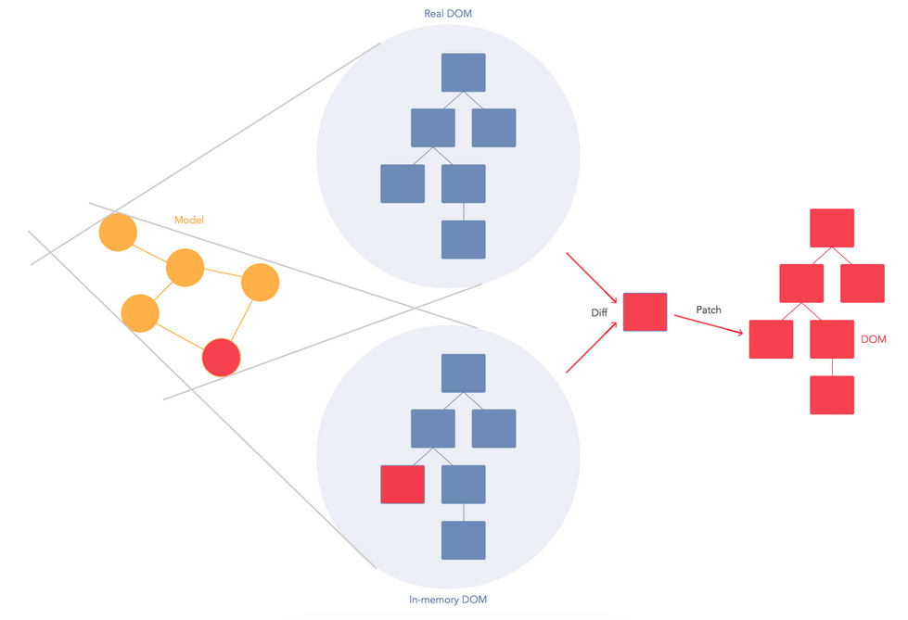

**Fig 2: Caption2**

React combines DOM generation and display logic. It is designed to re-render the whole app on every update via state, and its implementation consists of Virtual DOM and synthetic events. These best practices make React a powerful tool for developing your web applications.

The framework cannot know how to separate your concerns for you. It should only provide powerful expressive tools for the user to do it correctly.

Instead of templates, we can use components to separate your concerns. React components are highly cohesive building block for UIs loosely coupled with other components. In React these components are written in JavaScript, which is highly powerful.

React Components are thus :

* Reusable
* Composable
* Highly Cohesive
* Unit testable

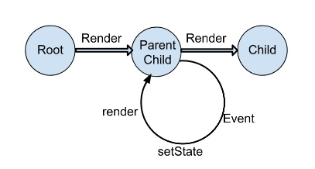

**Fig 3: Rendering and State Management in React**

Some definitions:

*JSX* : JSX is an optional preprocessor to let you use HTML-like syntax. With JSX, it’s easy for designers to contribute code.

*State* : Re-rendering the whole app on every update makes React stand out from other front-end libraries/frameworks.

Data changing over time can make it really difficult for the front-end developer. When data changes, React re-renders the entire component. So the React components describe your UI at any point in time, just like a server-rendered app. This means every place data is displayed is guaranteed to be up-to date.

*Virtual DOM* : In memory snapshot of DOM used by React to diff and update only those components that are required.

React is optimized for performance and memory footprint.

On every update to the component, React:

* Builds a new virtual DOM subtree
* Diffs it with the old one
* Computes the minimal set of DOM mutations and puts them in a queue
* And batch executes all updates

React can run in Node.js with optimizations based on app structure. React also has SVG, VML and <canvas> support, and can run the whole app in a Web Worker (experimental).

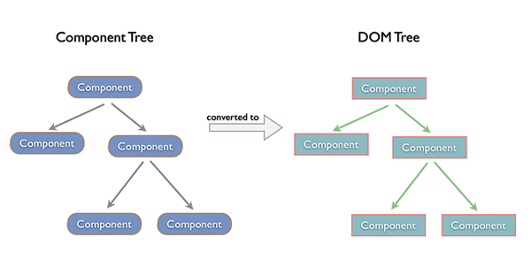

**Fig 4: Creation of DOM Tree**

The component based architecture can be implemented using React, which allows for generating applications by simply replacing, removing or adding components.

**2.5. Redux**

Redux is a microlibrary often used on top of React to manage the state with a minimal API but completely predictable behaviour i.e. it’s a predictable state container for JavaScript apps.

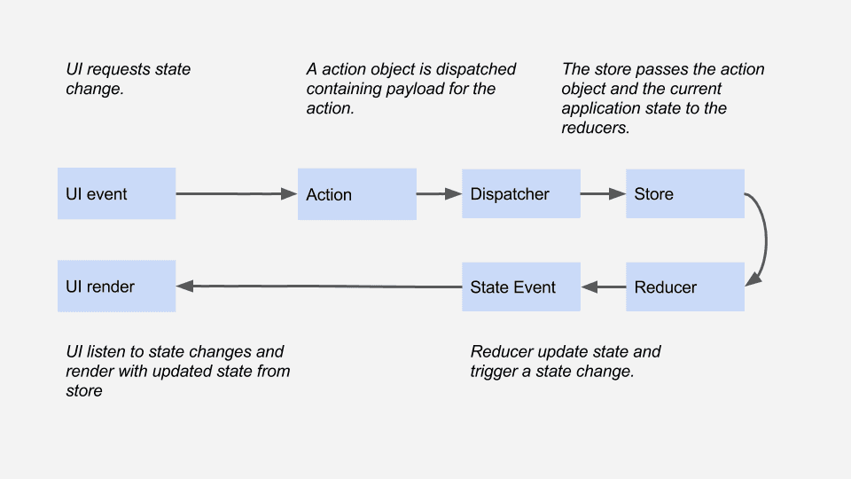

**Fig 5: Caption5**

Redux is:

* Simple, conceptually and in file size (2kb)
* Has predictable state transitions
* Single source of truth for UI state
* Highly performant
* Easily testable

To understand Redux, we need to look into the following concepts :

* Actions and action creators
* Reducers
* Store
* Middleware

*Actions* : Actions are payloads of information that send data from your application to your store. They are the only source of information for the store. You send them to the store using store.dispatch().

*Action Creators* : Action creators are the functions that return the body of an action.

*Reducers* : Actions describe the fact that something happened, but don’t specify how the application’s state changes in response. This is the job of a reducer. It updates the state according to those actions. Reducers are pure functions with the signature (previousState, action) => newState.

*Store* : Store is a wrapper around a JavaScript object (state). A store has two key methods: getState, and dispatch. If you are using something like react-redux, you don’t have to deal with these functions directly.

*Middleware*: It provides a third-party extension point between dispatching an action, and the moment it reaches the reducer. People use Redux middleware for logging, crash reporting, talking to an asynchronous API, routing, and more.  
Recommended middleware: thunk, redux-promise and batched-updates.

Hence, Redux is powerful for building predictable, testable, maintainable interfaces. This helps us further to maintain state in a highly cohesive system.

**2.6 NodeJS**

Node.js is an open-source, cross-platform runtime environment for developing server-side web applications. Node.js applications are written in JavaScript and can be run within the Node.js runtime on OS X, Microsoft Windows, Linux, FreeBSD, NonStop, IBM AIX, IBM System z and IBM i. Its work is hosted and supported by the Node.js Foundation, a collaborative project at Linux Foundation.

Node.js provides an event-driven architecture and a non-blocking I/O API designed to optimize an application's throughput and scalability for real-time web applications. It uses Google V8 JavaScript engine to execute code, and a large percentage of the basic modules are written in JavaScript. Node.js contains a built-in library to allow applications to act as a stand-alone web server.

Node.js is used by IBM, Microsoft, Yahoo!, Walmart, Groupon, SAP, LinkedIn, Rakuten, PayPal, Voxer and GoDaddy.

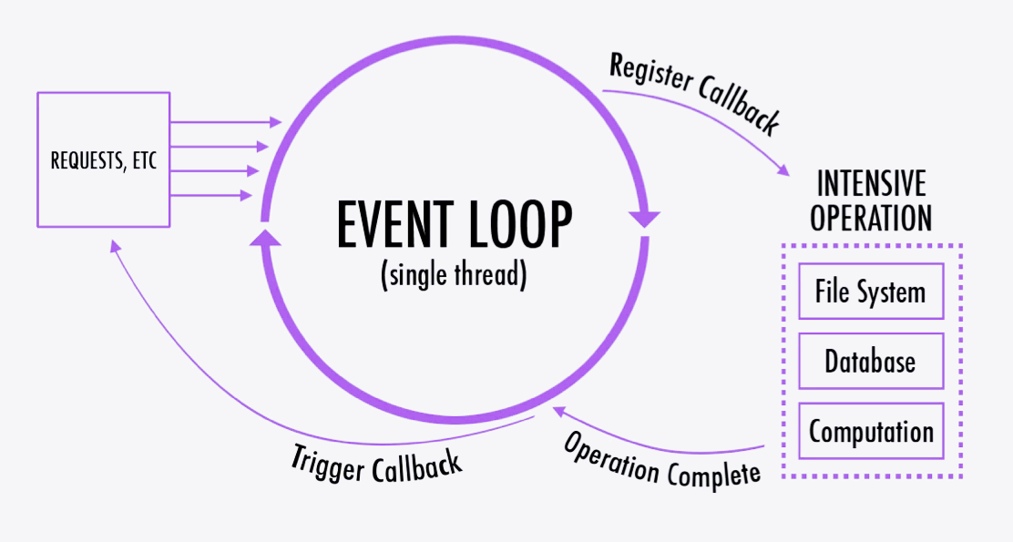

**Fig 6: Working of NodeJS**

The event loop and inherent CommonJS module system ensures high modularity and performance with the virtue of non blocking asynchronous calls to intensive operations. This not only benefits the server of the application but also our generator code. NodeJS is a perfect choice for our component based development engineering process.

* 1. **Express**

Express is a minimal and flexible Node.js web application framework that provides a robust set of features to develop web and mobile applications. It facilitates a rapid development of Node based Web applications.

Following are some of the core features of Express framework:

* Allows to set up middlewares to respond to HTTP Requests.
* Defines a routing table which is used to perform different action based on HTTP Method and URL.
* Allows to dynamically render HTML Pages based on passing arguments to templates.

ExpressJS layer helps us make scalable and pluggable code.

**Chapter 3**

**Software Requirements Specification**

3.1. Introduction

3.1.1. Purpose

3.1.2. Scope

3.1.3. Technologies Used

3.1.4. Overview

3.2. Overall Description

3.2.1. Product perspective

3.2.2. Product functions

3.2.3. User characteristics

3.2.4. Constraints

3.2.5. Assumptions

3.3. Specific Requirements

3.3.1. External Interface Requirements

3.3.2. Functional Requirements

3.3.3. Performance Requirements

3.3.4. Design Constraints

3.3.5. Non Functional Requirements

3.3.6. Other Requirements

3.4. Change Management Process

**3.1. Introduction**

This document is a Software Requirement Specification (SRS) for the Minimum Viable Product (MVP) Generator. SRS will be used for the extensions. The document is prepared as per the standard IEEE standard [9] for Software Requirement Specification.

* 1. **Purpose**

The purpose of this document is to present a detailed description of the Minimum Viable Product (MVP) Generator. It will explain the purpose and features of the system, the interfaces of the system, what the system will do, the constraints under which it must operate and how the system will react to external stimuli. Through this document, the workload needed for development, validation and verification will ease. To be specific, this document is going to describe functionality, external interfaces, performance, attributes and the design constraints of the system which is going to be developed.

**3.1.2. Scope**

This software system will be a Code Generator for startup owners with small development team or no team at all, to develop a certain kind of application which revolves around searching and reviewing of an entity (Restaurant, Gym, School, Home Tutor etc). This system will be designed to maximize the developer’s productivity by providing a simple command line interface tool to assist in automating the programming process, which would otherwise have to be performed manually by a large team of developers versed in different platforms and technologies.

By maximizing the developer’s work efficiency and production the system will allow the user of the system build a Minimum Viable Product which can be used to pitch the idea in front of investors or the generated application can be used as a scaffolding to build on top of. The details of application to generate are taken as command line arguments and configuration file.

**3.1.3 Technologies to be used**

**Programming language:**

**JavaScript**: JavaScript is a high-level, dynamic, untyped, and interpreted programming language. It has been standardized in the ECMAScript language specification. Alongside HTML and CSS, it is one of the three core technologies of World Wide Web content production; the majority of websites employ it and it is supported by all modern Web browsers without plug-ins. JavaScript is prototype-based with first-class functions, making it a multi-paradigm language, supporting object-oriented,[8] imperative, and functional programming styles. It has an API for working with text, arrays, dates and regular expressions, but does not include any I/O, such as networking, storage, or graphics facilities, relying for these upon the host environment in which it is embedded.

**Platforms:**

**NodeJS**: Node.js is an open-source, cross-platform runtime environment for developing server-side web applications. Node.js applications are written in JavaScript and can be run within the Node.js runtime on OS X, Microsoft Windows, Linux, FreeBSD, NonStop, IBM AIX, IBM System z and IBM i. Its work is hosted and supported by the Node.js Foundation, a collaborative project at Linux Foundation.

Node.js provides an event-driven architecture and a non-blocking I/O API designed to optimize an application’s throughput and scalability for real-time web applications. It uses Google V8 JavaScript engine to execute code, and a large percentage of the basic modules are written in JavaScript. Node.js contains a built-in library to allow applications to act as a stand-alone web server.

**Tools and Development Environment**

**NPM:** As of Node.js version 0.6.3, npm is bundled and installed automatically with the environment. Npm runs through the command line and manages dependencies for an application. It also allows users to install Node.js applications that are available on the npm registry. Npm is written entirely in JavaScript and was developed by Isaac Z. Schlueter as a result of the frustrations he had experienced while working with CommonJS and with inspiration from the shortcomings of other similar projects such as PHP (PEAR) and Perl (CPAN).

**Libraries**

Since the product will require a lot of libraries based on the requirements, developers are open to choose any set of libraries as found fit for high cohesion and modularity.

**3.1.4. Overview**

The next chapter, the Overall Description section, of this document gives an overview of the functionality of the product. It describes the informal requirements and is used to establish a context for the technical requirements specification in the next chapter.

The third chapter, Requirements Specification section, of this document is written primarily for the developers and describes in technical terms the details of the functionality of the product.

Both sections of the document describe the same software product in its entirety, but are intended for different audiences and thus use different language.

* 1. **Overall Description**

This section gives background information about specific requirements of the minimum viable product generator to be developed in brief. Although we will not describe every requirement in detail, this section will describe the factors that affect the final product.

options

End-User

Generated application

**Fig 7: Context diagram of MVP Generator**

The MVP Generator has one active actor and one system. The End-User The Author, Reader, or Reviewer accesses the Online Journal through the Internet. Any Author or Reviewer communication with the system is through email. The Editor accesses the entire system directly. There is a link to the (existing) Historical Society.

**3.2.1. Product Perspective**

This software product is eventually intended to automate the process of development of modern day web based applications in a modular and component based approach. Product will be deployed to website and mobile platforms and users of the product will access it on these platforms. Website and mobile platforms will serve as the interface for the user data and the execution of provided functionalities.

This product generator cuts down the development process to merely seconds. The end-user will supply an options file describing the entity and other aspects of the project, and the generator would work its way out to compile entire service including Server, Database Configuration, Website & Mobile Applications.

There are other generators in industry like YeoMan [10]. However they aren’t focussed for this niche of applications and relies entirely on user posted generation logic, which again is limited in terms of functionality.

**3.2.2. Product Functions**

This new product allows users to use functionalities which have been explained above in the introduction. Required functionalities of the product can be summarized in five categories; user management requirements, code editor requirements, debugger requirements, command line interface requirements and interface requirements. Overall description of the requirements can be found below;

The generator will only have one function, that is to generate application based on inputs given.

This main function gets input from the CLI and responds by creating a folder in the same directory.

The function may use several modules to implement different stages of generation.

**3.2.3. User Characteristics**

* Users of this minimum viable product generator can be of any field.
* Target users have some application development knowledge to no knowledge at all.
* End-user is educated with basic computer usage.
* End-user has some experience with CLIs.

**3.2.4. Assumptions**

* User has Unix based Operating System, preferably Mac OS X for smooth development of iOS and Android applications.
* User doesn’t have windows.
* User has active internet connection.
* User has NodeJS installed.
* User has working knowledge of JavaScript.
  1. **Specific Requirements**

With this section and later, we will describe the requirements of the product in detail. Basically, we will categorize requirements in three which are namely external interface requirements, functional requirements and non-functional requirements. Except non-functional requirements, requirements of the product will be detailed under this section with brief information.

* + 1. **External Interface Requirements**
* **User Interface Requirements:** User friendly interface is required for giving him textual cues regarding the process running while generation. A README file is to be provided in the generated application that explains the installation process.
* **Hardware Interface Requirements:** There are no hardware interface requirements.
* **Communication Interface Requirements:** Communication is nowhere involved. So, there are no communication interface requirements.

**Design of CLI**

**$** mvpgenerate .

**>** Name of Application ? ________

**>** Database details ? _________

**>** Choice of Theme ? __________

**>** Parsing options file (100%)

**>** Generating database modules (100%)

**>** Generating server modules (100%)

**>** Generating UI modules (100%)

**>** Optimizing & cleaning (100%)

Your project has been successfully generated in ./LawyerFinder directory !

**3.3.2. Functional Requirements**

* Main function: Takes input and generates application based on the inputs provided.
  + Configuration File Specification:

'use strict';

const levels = ['primary', 'secondary', 'primary_secondary'];

const streams = ['nonmed', 'med', 'commerce'];

module.exports = {

// Search by parameters, these will appear in the "Filters" while searching, and the api will use these to allow searching based on these.

search: [

{ by: 'level', type: 'enum', options: levels, },

{ by: 'twelfth_streams', type: 'enum', options: streams, },

],

// Meta data about entity

entity: {

// Attributes of entity that are extra to the default ones

attributes: [

{ name: 'level', type: 'enum' , options: levels, },

{ name: 'twelfth_streams', type: 'enum', options: streams, },

],

},

};

**3.3.3. Performance Requirements**

* Application should be generated within 60-120 seconds on broadband connection.
* Generated application should be responsive in design.

**3.3.4. Design Constraints**

* 1. **Development Tools**

The system shall be built using JavaScript, Vim Text Editor and NodeJS.

* 1. **Online Product**

Node Package Manager shall be used for installation of dependencies of the project.

* 1. **Database**

Database is required by the generated application but not the generator itself.

**3.3.5. Non Functional Requirements**

1. Security – Generated application shall use JSON Web Tokens for security of user authentication system.
2. Usability - The system shall be easy to use and understand. User will only need to give inputs about the application. All other functions will be automated and internal to generation process.
3. Maintainability – Component driven development and modular structure shall ensure maintainable code.
4. Portability - The application is JavaScript based and should be compatible with all other systems. The end-user part is fully portable and any system should be able to use the features of the application, including any hardware platform that is available or will be available in the future.

**3.3.6. Other Requirements**

**Schedule and Budgets**

The model of this project is to be proposed by 26th May 2015. Due to lack of funding, implementation of mobile applications with finished quality is outside the scope of the project. This project includes proposing model and a working of generation system.

**3.4. Change Management Process**

The SRS is developed in such a manner that any desired changes can be introduced by the designing party in the near future according to the suitability.

**Chapter 4**

**Model Proposed**

Our strategy to build the generator was to divide development process into two phases of Skeleton and Generator development.

Skeleton represents a basic structure of search centric application, including server side code. The more customizable skeleton is, the easier It becomes to generate code.

Second phase uses the Skeleton to tweak and adjust its code to fulfil the requirements of the user as described by the user.

We first discuss how skeleton is developed. Generator relies on customizability and modularity of the skeleton to generate different kinds of applications.

Client

Server

**Fig 8: Layers in MVP generator**

We layered the entire application into 4 major parts:

* ORM
* API
* Component Fetch
* Component UI

**Object Mapping Layer (ORM)**

This layer is the closest to database and hence furthest from end-user. The layer is used to model Entities from the database as models that can be used elsewhere in the code.

This is sample Entity Relation Model that is followed internally in the schema. Note that schema gets modified by the generator to accommodate attributes provided by the user, hence it’s not possible to determine all attributes before hand.



**Fig 9: ER Diagram of the skeleton for generator**

**API**

This is the second layer that acts as a controller between requests from client side and the database entities.

Each entity has its own set of APIs, in a separate module. This ensure high cohesion.

Following APIs are developed

* **Users:** Deals with functions of User, such as login, logout, signup, get profile, edit profile etc.
* **Entities:** Deals with functions of Entity, such as create, search, modify entity.
* **Reviews:** Deals with functions of Reviews, such as adding review, editing review and deleting review.
* **Ratings:** Deals with rating of an entity by a registered user.
* **Bookmarks:** Deals with bookmarking of entity by a registered user.

**Component Fetch**

Now we enter the client side. This layer deals with communication with the server and update client state data using Redux store.

A fetch call is HTTP request to server with payload, as explained in Application Development in 2.1.

Redux Store has user authentication and current entity data. Rest of the state is stored by internal states of Components.

**Component UI**

Components are core part of React Library. These help in encapsulating the UI logic into composable components and also save state within each component which can be changed on basis of events listened by the component. Change in state leads to updating of node sub tree from the affected component’s node.

Components are divided into two categories

* **Layout:** These possess no state and simply serve as layout templates on the basis of properties sent by parent components
* **Container:** These contain state and perform communication with server. The response data is used to update the state, which then leads to re-rendering of layout components that are children to the container component.

Following is a component tree for Entity page in the application.

**Fig 10: Component tree of the entity page**

**Chapter 5**

**Conclusion and Results**

* The generator was successfully built in schedule, meeting requirements as described in the SRS.
* We were able to generate diverse applications like School Finder, Gym Finder and a Banquet Hall Searcher.
* Attached CD includes the source code of the generator.
* Screenshots of the application are attached with the CD.

**Chapter 6**

**Future Scope**

* The generator can support custom plugins that intercept the building process to inject, modify or even remove components to allow custom functionality provided to generator.
* Further, the generator can not only generate but update existing applications built using the generator to perform transformations to code like removal of certain components, replacement of component with some other alternative, etc.
* With proper funding, native mobile applications can be developed using React Native technology to provide better functionality set by the generator.
* Windows support can be added once dependencies support Windows.

**Chapter 7**

**References**

1. Mobile Internet Users In India 2016: 371 Mn by June, 76% Growth In 2015 - <http://dazeinfo.com/2016/02/08/mobile-internet-users-in-india-2016-smartphone-adoption-2015/>
2. India Restaurants - Find the best restaurants, cafés and bars in India on ... <http://zomato.com/>
3. Find & book appointments with doctors, diagnostic labs, salons, gyms & spas. Ask free health questions to doctors or get free tips from health experts. <https://www.practo.com/>
4. CarWale - Search New, Used Cars <http://carwale.com/>
5. Ivica Crnkovic, Michel Chaudron, Stig Larsson,“Component-based Development Process and Component Lifecycle”,2006
6. Kuda Nageswara Rao, G. Kavita Naidu, Praneeth Chakka, “A Study of the Agile Software Development Methods, Applicability and Implications in Industry”,2011
7. A B M Moniruzzaman, Dr Syed Akhter Hossain, “Comparative Study on Agile software development methodologies”,[4] Beck, Kent; et al. (2001).
8. "Principles behind the Agile Manifesto". Agile Alliance. Archived from the original on 14 June 2010. Retrieved 6 June 2010
9. IEEE. IEEE Std 830-1998 IEEE Recommended Practice for Software Requirements Specifications. IEEE Computer Society, 1998.

[10] The web's scaffolding tool for modern webapps. <http://yeoman.io/>